Ex. No.: 5 PROCESS CODE INJECTION
Aim:
To do process code injection on Firefox using ptrace system call.

Algorithm:
1. Find out the pid of the running Firefox program.
2. Create the code injection file.
3. Get the pid of the Firefox from the command line arguments.
4. Allocate memory buffers for the shellcode.
5. Attach to the victim process with PTRACE_ATTACH.
6. Get the register values of the attached process.
7. Use PTRACE_POKETEXT to insert the shellcode.
8. Detach from the victim process using PTRACE_DETACH

Output:
[root@localhost ~]# vi codeinjection.c
[root@localhost ~]# gcc codeinjection.c -o codeinject
[root@localhost ~]#ps -e|grep firefox
1433 ? 00:01:23 firefox
[root@localhost ~]# ./codeinject 1433
----Memory bytecode injector-----
Writing EIP 0x6, process 1707
[root@localhost ~]#

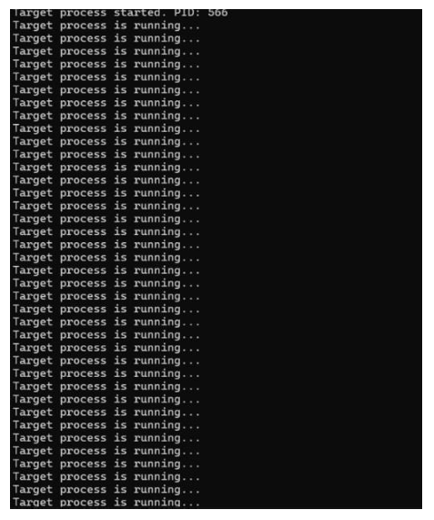
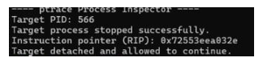

Result:
Thus, the process code injection on Firefox has been successfully executed. 14

